Standardformulär för paketresor
Använd texten i den blå rutan. Fyll i det som saknas enligt instruktionen på vår webbplats. Informationstexten ska delas ut innan bindande avtal ingås.

Exempel
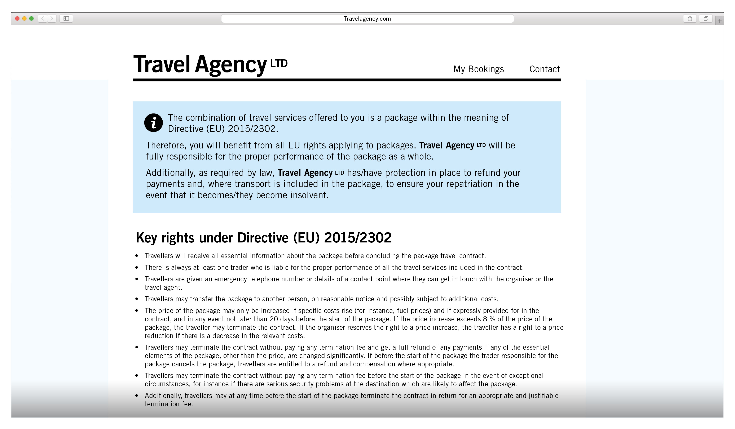

Informationstext
The combination of travel services offered to you is a package within the
meaning of Directive (EU) 2015/2302.

Therefore, you will benefit from all EU rights applying to packages. Company/companies "XY" will be fully responsible for the proper performance
of the package as a whole.

Additionally, as required by law, company/companies "XY" has/have protection
in place to refund your payments and, where transport is included in the package, to ensure your repatriation in the event that it becomes/they become insolvent.

Key rights under Directive (EU) 2015/2302
- Travellers will receive all essential information about the package before concluding the package travel contract.
- There is always at least one trader who is liable for the proper performance of all the travel services included in the contract.
- Travellers are given an emergency telephone number or details of a contact point where they can get in touch with the organiser or the travel agent.
- Travellers may transfer the package to another person, on reasonable notice and possibly subject to additional costs.
- The price of the package may only be increased if specific costs rise (for instance, fuel prices) and if expressly provided for in the contract, and in any event not later than 20 days before the start of the package. If the price increase exceeds 8 % of the price of the package, the traveller may terminate the contract. If the organiser reserves the right to a price increase, the traveller has a right to a price reduction if there is a decrease in the relevant costs.
- Travellers may terminate the contract without paying any termination fee and get a full refund of any payments if any of the essential elements of the package, other than the price, are changed significantly. If before the start of the package the trader responsible for the package cancels the package, travellers are entitled to a refund and compensation where appropriate.
- Travellers may terminate the contract without paying any termination fee before the start of the package in the event of exceptional circumstances, for instance if there are serious security problems at the destination which are likely to affect the package.
- Additionally, travellers may at any time before the start of the package terminate the contract in return for an appropriate and justifiable termination fee.
- If, after the start of the package, significant elements of the package cannot be provided as agreed, suitable alternative arrangements will have to be offered to the traveller at no extra cost. Travellers may terminate the contract without paying any termination fee, where services are not performed in accordance with the contract and this substantially affects the performance of the package and the organiser fails to remedy the problem. 11.12.2015 L 326/25 Official Journal of the European Union EN
- Travellers are also entitled to a price reduction and/or compensation for damages where the travel services are not performed or are improperly performed.
- The organiser has to provide assistance if the traveller is in difficulty.
- If the organiser or, in some Member States, the retailer becomes insolvent, payments will be refunded. If the organiser or, where applicable, the retailer becomes insolvent after the start of the package and if transport is included in the package, repatriation of the travellers is secured. "XY" has taken out insolvency protection with "YZ (the entity in charge of the insolvency protection, e.g. a guarantee fund or an insurance company)". Travellers may contact this entity or, where applicable, the competent authority Kammarkollegiet, Birger Jarlsgatan 16, 114 34 Stockholm, 08-700 08 00, registratur@kammarkollegiet.se if services are denied because of "XY"'s insolvency.

https://svenskforfattningssamling.se/doc/20181217.html

